**Django Internship Report**

**Personal Details**

Name : Nishant Movaliya

College Name : Government Engineering College,Modasa

Degree : BE

Semester : 7

Github URL : <https://github.com/nishantmovaliya>

**Company Details**

Company Name : Akash Technolabs

External Guide : Akash Padhiyar

Training Duration : 26-05-2021 to 21-06-2021

**Index**

|  |  |  |
| --- | --- | --- |
| **Index** | **Task Detail** | **Page Name** |
| 1 | Hello World | 1 |
| 2 | Fetch Data From Database | 2 |
|  |  |  |
|  |  |  |
|  |  |  |

**Task-1:**

**Basic HTML based : To Create Registration form using div/table.**

**registration_form.html**

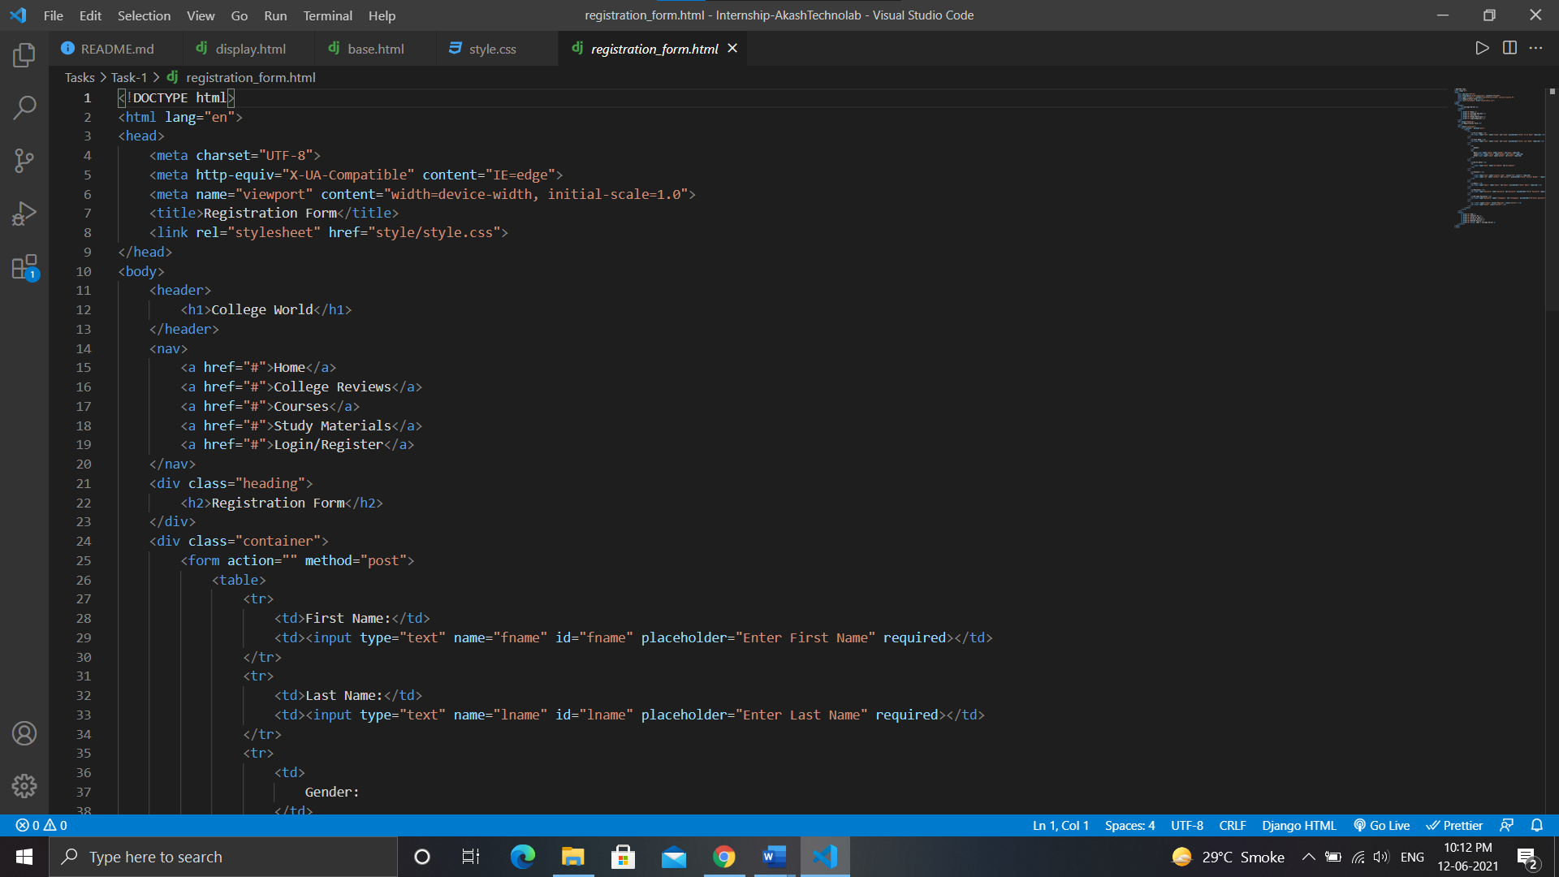

Output:

